**Questions**

1. What is the smallest memory object that can represent a character of information?

A BIT is the smallest memory object that can represent a character of information

* 1. Think… How many upper case letters in the alphabet (A to Z)?

26 Letters

* 1. Think… How many lower case letters in the alphabet (a to z)?

26 Letters

* 1. Think… How many number digits (0 to 9)?

10 digits

* 1. Think… How many punctuation marks?

14 punctuation marks

* 1. Add them all up  
     76…?

1. Research the ASCII characters set. What is it and how is it related to computer memory?  
   ASCII is a 7-bit code, representing 128 different characters. When an ASCII character is stored in a byte the most significant bit is always zero. Sometimes the extra bit is used to indicate that the byte is not an ASCII character, but is a graphics symbol, however this is not defined by ASCII. If text is being stored in a computer, it is usually stored as a string (a series of ASCII characters, each one of which is stored as one byte).
2. How are strings of characters (Google “String”) represented in computer memory?

Strings of characters are each stored as one byte.

1. How are negative integers represented in computer memory? (Include a diagram)  
   Negative signed integers are stored in what is called two's complement. The other major way of storing negative signed numbers is called one's complement.

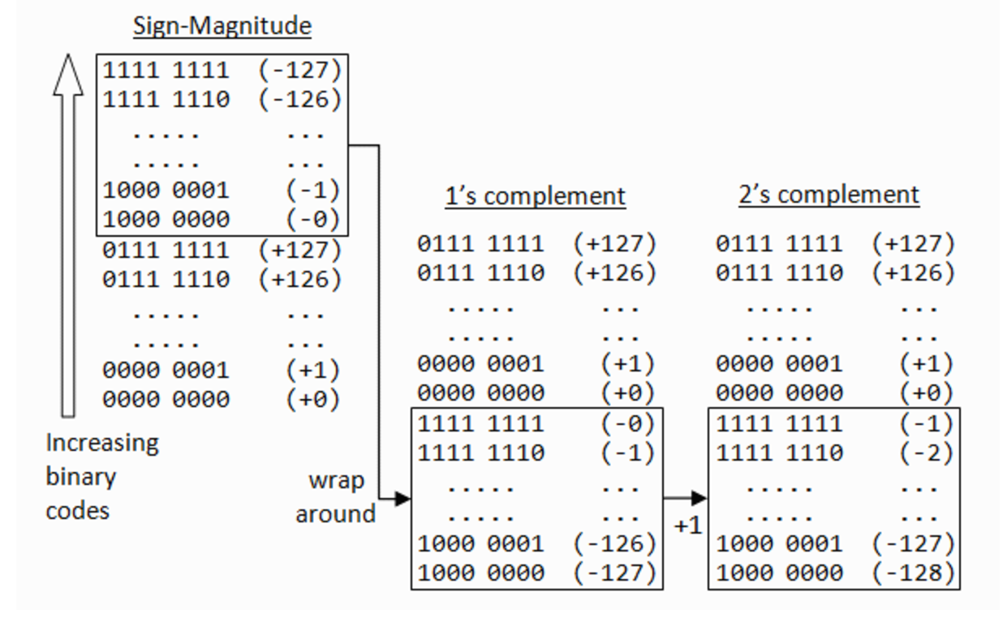

1. How are decimal numbers (Google “Floating Point”) represented in computer memory? (Include a diagram)  
   In memory, a floating point number is represented similarly: One bit has the sign, some bits form the factor as a fixed-precision number (“mantissa”), the remaining bits form the exponent. Significant differences to base-10 engineering notation is that of course now the exponent has base 2. The exact size of each part depends on the exact floating-point standard you are using.

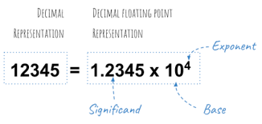

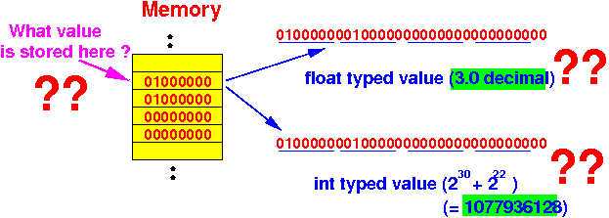

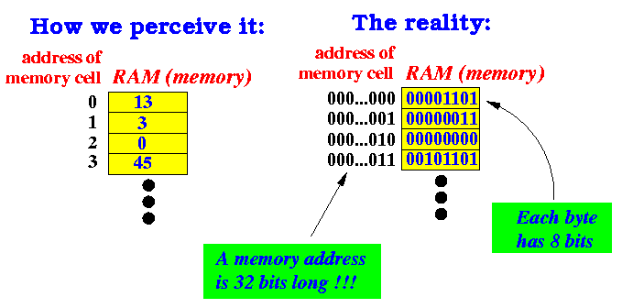 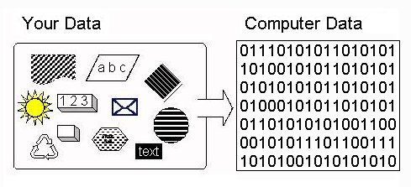

1. A Pixel is computer memory structure used to store image information. How is a Pixel represented in memory? (Include a diagram).

Pixels are the smallest individual element in an image, holding antiquated values that represent the brightness of a given color at any specific point. Typically, the pixels are stored in computer memory as a raster image or raster map, a two-dimensional array of small integers. 